FEDERAL ROADS MAINTENANCE AGENCY
PLOT 163 AMINU KANO CRESCENT, WUSE II, ABUJA
Dept; PROCUREMENT
Email:

Telephone:234 (9) 3146536
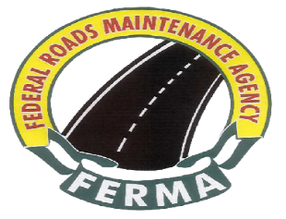
Ref: FERMA/PCM/ADVERT/CORR/CSO/26/I/029
Date: 8th September, 2026
.

The Director General
Bureau of Public Procurement
Plot 256, ZoneAO, Off Herbert Macaulay
Central Business District
Abuja .

INVITATION TO WITNESS BID OPENING
THE GENERAL MAINTENANCE OF SELECTED FEDERAL ROADS AND CONSULTANCY SERVICE

Pursuant to section 19(b) of the Public Procurement Act, 2007, the Federal Roads Maintenance Agency (FERMA) hereby invites your organization to witness the bid opening exercise for Selected Federal Roads and other Works Nationwide

2.0 The exercise is scheduled to take place as follows:

- Date: Tuesday 22nd September, 2026

- Time: 12:00 Noon

- Venue: Federal Roads Maintenance Agency Conference Hall, 2nd
Floor, Aminu Kano Crescent, Wuse II, Abuja

3.0 While thanking you for your usual cooperation, please accept the assurance of my esteemed regards always.

Signed
The Management

