FEDERAL ROADS MAINTENANCE AGENCY
PLOT 163 AMINU KANO CRESCENT, WUSE II, ABUJA

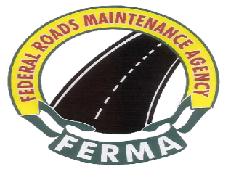
Ref: FERMA/PCM/ADVERT/CORR/CSO/26/I/034
Date: 28th September, 2026
.

Dept; PROCUREMENT
Email:

Telephone:234 (9) 3146536
The Director General
Bureau of Public Procurement
Plot 256,ZoneAO, Off Herbert Macaulay
Central Business District
Abuja

INVITATION TO WITNESS BID OPENING
FINANCIAL BID FOR THE CONSULTANCY SERVICES.

Pursuant to section 19(b) of the Public Procurement Act, 2007, the Federal Roads Maintenance Agency (FERMA) hereby invites your organization to witness the Financial bid opening for the Provision of Security Services.

2.0 The exercise is scheduled to take place as follows:

- Date: Tuesday, 6th October, 2026

- Time: 12:00 Noon

- Venue: Federal Roads Maintenance Agency Conference Hall, 2nd
Floor, Aminu Kano Crescent, Wuse II, Abuja

3.0 While thanking you for your usual cooperation, please accept the assurance of my esteemed regards always.

Signed
The Management

