FEDERAL ROADS MAINTENANCE AGENCY
PLOT 163 AMINU KANO CRESCENT, WUSE II, ABUJA
Dept; PROCUREMENT
Email:

Telephone:234 (9) 3146536
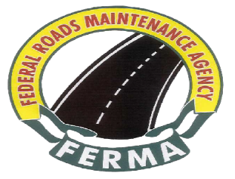
Ref: FERMA/PCM/ST/CORR/CSO/26/I/039
Date: 5th October, 2026
.

The Director General
Bureau of Public Procurement
Plot 256,ZoneAO, Off Herbert Macaulay
Central Business District
Abuja

INVITATION TO WITNESS BID OPENING
URGENT REHABILITATION AND MAINTENANCE WORKS ON CRITICAL FEDERAL ROADS AND OTHER WORK ITEMS ACROSS THE FEDERATION UNDER THE 2026 APPROPRIATION ACT PHASE II
Pursuant to section 19(b) of the Public Procurement Act, 2007, the Federal Roads Maintenance Agency (FERMA) hereby invites your organization to witness the bid opening exercise for Selected Federal Roads and other Works Nationwide

- The exercise is scheduled to take place as follows:

- Date: Monday 19th October, 2026

- Time: 12:00 Noon

- Venue: Newton Park Hotel & Resort Annex, Alexandria Crescent, Off Ahmadu Bello Way, by Banex Junction, Wuse II, Abuja

- While thanking you for your usual cooperation, please accept the assurance of the Managing Director's esteemed regards always.

Signed
The Management

